**ASSIGNMENT 24.5**

* Using database:-

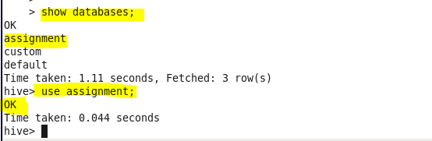

* Creating table:-

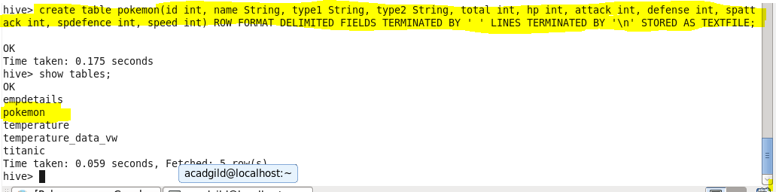

* Loading data from data file:-

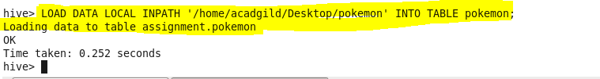

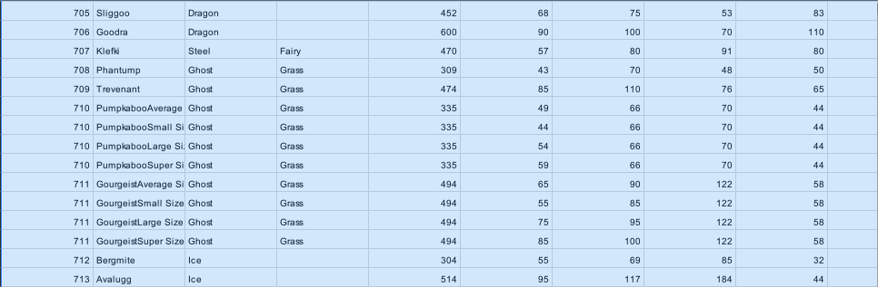

* **Find out the average HP (Hit points) of all the Pokémons?**

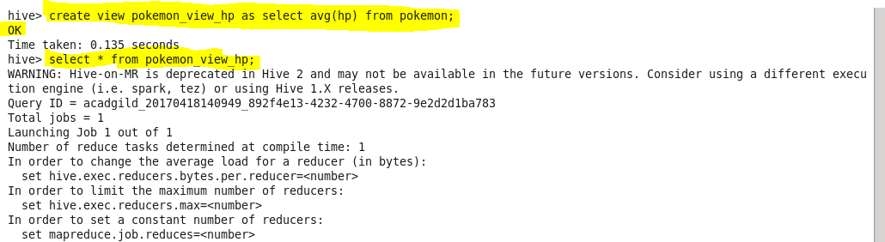

**Output:-**

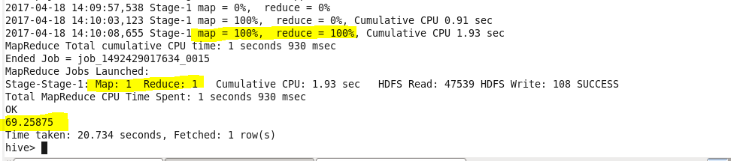

* **Find out the average Defense of all the pokemon**

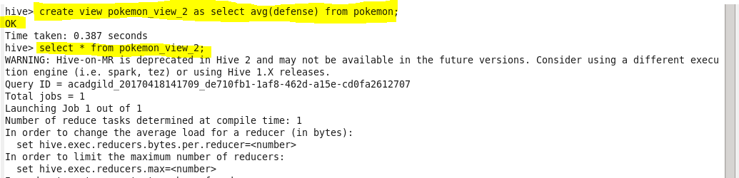

**Output:**

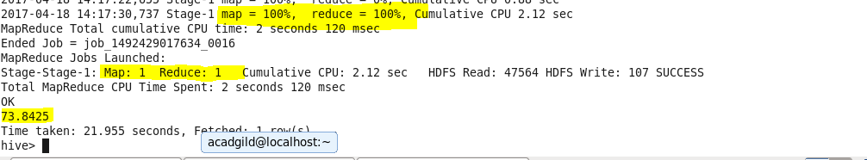

* **Find out the average Sp.Atk of all the pokemons?**

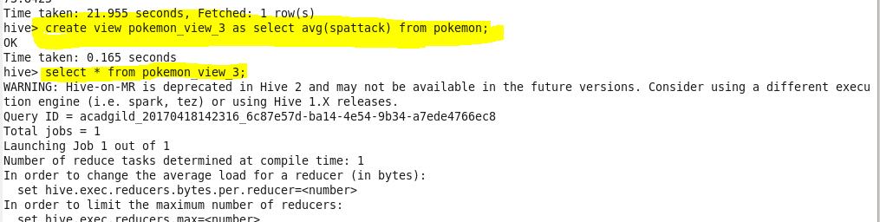

**Output:-**

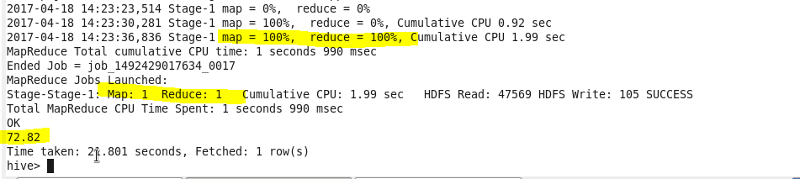

* **Find out the average sp.Def of all the pokemons?**

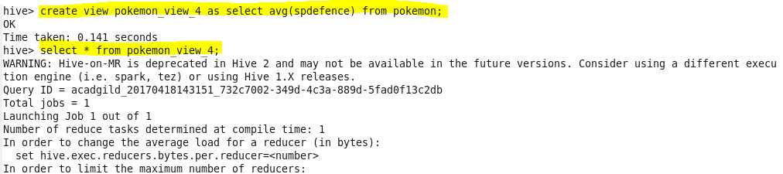

**Output:**

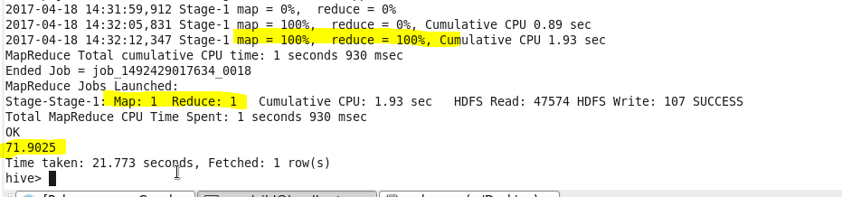

* **Find out the average Speed of all the pokemons**

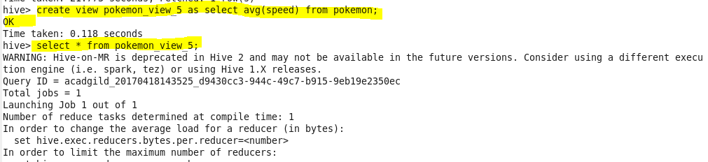

**Output:-**

